**Patient Diagnosis Report**

#(1) Write a query to create a patients table with the fields such as date, patient id, patient name, age, weight, gender, location, phone number, disease, doctor name, and doctor id.

Create database patient_diagnosis;

Use patient_diagnosis;

Create table patients(

dates varchar(12),

patient_id varchar(50),

patient_name char(12),

age int,

weight int,

gender char(10),

location char(50),

phone_number int,

disease char(50),

doctor_name char(50),

doctor_id int

);

#(2) Write a query to insert values into the patients table

#(3) Write a query to display the total number of patients in the table -- Start with select then Count command (*) As New column name From table name

#(4) Write a query to display the patient id, patient name, gender, and disease of the patient whose age is maximum -- List the columns then add from the selected table then the where command age (select max() from table)

#(5) Write a query to display patient id and patient name with the current date -- select column names followed by the NOW function as the new column name from the table set

#(6) Write a query to display the old patient’s name and new patient's name in uppercase -- select the ucase command followed by column and from table

#(7) Write a query to display the patient’s name along with the length of their name -- select the chosen column followed by the length command of the selected column AS new column name from table

#(8) Write a query to display the patient’s name, and the gender of the patient must be mentioned as M or F -- Select first column name followed by the IF function

#(9) Write a query to combine the names of the patient and the doctor in a new column -- 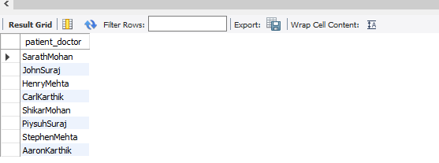

#(10) Write a query to display the patients’ age along with the logarithmic value (base 10) of their age --Use the LOG10 command

#(11) Write a query to extract the year from the given date in a separate column -- extract command

#(12) Write a query to return NULL if the patient’s name and doctor’s name are similar else return the patient’s name -- IF command

#(13) Write a query to return Yes if the patient’s age is greater than 40 else return No -- If command

#(14) Write a query to display the doctor’s duplicate name from the table -- Using COUNT and GROUP BY keywords to eliminate the duplicate records.

